LAB
1. User-Defined Data Types

(A) Composite Types (Similar to Structs in C or Classes in OOP)

A composite type is a collection of multiple attributes, just like a class in Object-Oriented Programming (OOP).

Example: Creating a Custom Address Type

-- Create a user-defined composite type
CREATE TYPE Address AS (
street TEXT,
city TEXT,
zipcode INT
);
-- Use this type in a table
CREATE TABLE Hospital (
id SERIAL PRIMARY KEY,
name TEXT,
location Address -- Using user-defined type
);
-- Insert values using ROW()
INSERT INTO Hospital (name, location)
VALUES ('City Hospital', ROW('123 Main St', 'New York', 10001));
-- Fetch data
SELECT * FROM Hospital;
- Fetch the street from the composite type.
SELECT name, (location).street FROM Hospital;
- Fetch all the city
- Update zip code from 10001 to 20001.
Update hospital
Set location.zipcode =2001
Where id =1;
- Add one more column to custom address
ALTER TYPE Address ADD ATTRIBUTE country TEXT;
- Update country to USA

2. ENUM Types (Predefined Set of Values)

ENUM is a user-defined data type that restricts a column to specific values.
Example: Defining an ENUM Type for Blood Groups
-- Create an ENUM type

CREATE TYPE BloodGroup AS ENUM ('A+', 'A-', 'B+', 'B-', 'O+', 'O-', 'AB+', 'AB-');

-- Use ENUM in a table
ALTER TABLE Patients ADD COLUMN blood_type BloodGroup;

Try this below cmds:
- update patients set blood_type='a' where patientid=101;
- update patients set blood_type='a+' where patientid=101;
- update patients set blood_type='A+' where patientid=101;
- insert into patients (patientid,age) values (106,-25);

DOMAIN
- A custom data type based on an existing type with optional constraints.
- When you want rules like value range, format, or NOT NULL on top of an existing type.
- Example: Positive integer age
CREATE DOMAIN PositiveAge AS INT CHECK (VALUE > 0);
ALTER TABLE Patients ALTER COLUMN age TYPE PositiveAge;

- Now try - insert into patients (patientid,age) values (106,-25);
- INSERT INTO Patients (PatientID, Name, DoctorID) VALUES (106, 'Kiran', NULL);

JOINS
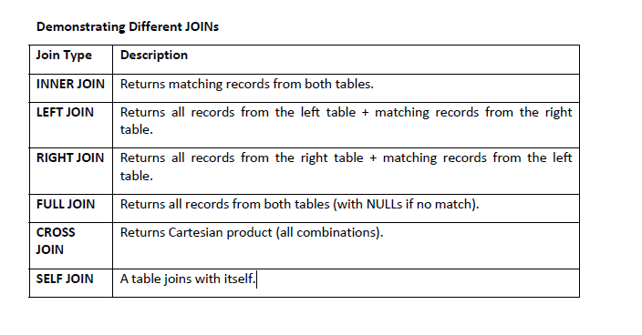

1. cross join
Cartesian product → every patient paired with every doctor.
select * from patients cross join doctors;

2. INNER JOIN
Returns only matching records (patients with assigned doctors).
select * from patients p inner join doctors d on p.doctorid=d.doctorid;
write a query to display patients name with assigned doctor name.

3. LEFT JOIN
All patients, even if they don’t have a doctor.
select * from patients p left join doctors d on p.doctorid=d.doctorid;

4. RIGHT JOIN
All doctors, even if they don’t have patients.
select * from patients p right join doctors d on p.doctorid=d.doctorid;

5. FULL JOIN
- All patients and all doctors, matched where possible.
- Combines LEFT + RIGHT JOIN
- Unmatched patients or doctors → NULLs
select * from patients p full join doctors d on p.doctorid=d.doctorid;

6. SELF JOIN
Table joins with itself. Example: finding patients with the same doctor.
select p1.name,p2.name from patients p1 join patients p2 on p1.doctorid=p2.doctorid and p1.patientid<p2.patientid;

GROUP BY in PostgreSQL
GROUP BY
The GROUP BY clause in PostgreSQL is used to group rows that have the same values in one or more columns and then apply aggregate functions like COUNT(), SUM(), AVG(), MIN(), MAX() on them.
Basic Syntax
SELECT column_name, AGGREGATE_FUNCTION(column_name)
FROM table_name
GROUP BY column_name;
The column in the SELECT statement must either be:
1. Included in the GROUP BY clause
2. Used with an aggregate function
Example:
1. Count number of patients by Gender
select gender, count(*) from patients group by gender;
2. Count patients per Doctor (Try this)

3. SELECT Name, COUNT(*) FROM Patients GROUP BY Gender;

4. Group by YEAR
SELECT EXTRACT(YEAR FROM AdmissionDate) AS year, COUNT(*)
FROM Patients
GROUP BY EXTRACT(YEAR FROM AdmissionDate);

5. Group by MONTH
SELECT EXTRACT(MONTH FROM AdmissionDate) AS month, COUNT(*)
FROM Patients
GROUP BY EXTRACT(MONTH FROM AdmissionDate);

6. Group by DATE (day-wise)
- Use this when AdmissionDate is TIMESTAMP
SELECT DATE(AdmissionDate) AS admit_date, COUNT(*)
FROM Patients
GROUP BY DATE(AdmissionDate);

HAVING Clause (Filtering After GROUP BY)

- The HAVING clause is used to filter groups after aggregation (similar to WHERE, but for grouped results).
Example: 1. Doctors having more than 3 patients
SELECT doctorid, COUNT(*) AS total_patients
FROM Patients GROUP BY doctorid HAVING COUNT(*) > 3;
2. Admission dates having more than 2 patients admitted

GROUP BY Multiple Columns
SELECT col1, col2, aggregate_func(*)
FROM table
GROUP BY col1, col2;
Explanation:
- Groups by both category and author
- Calculates the total sales per category and author
Try this:

1. Display doctor_id, Doctors_name having more than 2 patients
2. Display Doctors having patients admitted on more than 3 different dates


